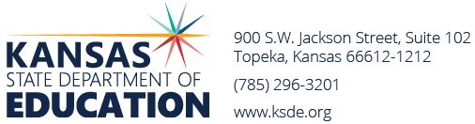
Revised May 8, 2024
2023-24 Bonds Requested

2022-2023 Bonds Retired + PPI (Cap) = $607,123,770

USD | District Name | Election Date | Amount Requested | * Amount Against Cap
205 | Bluestem | 8/29/23 | 13,515,000 | 0
219 | Minneola | 11/7/23 | 15,010,000 | 0
343 | Perry | 11/7/23 | 17,800,000 | 0
372 | Silver Lake | 11/7/23 | 16,365,000 | 12,674,255
395 | La Crosse | 11/7/23 | 10,975,000 | 0
479 | Crest | 11/7/23 | 5,950,000 | 0
410 | Durham-Hillsboro-Lehigh | 1/23/24 | 13,350,000 | 9,206,165
409 | Atchison | 2/1/24 | 27,300,000 | 18,415,664
458 | Basehor-Linwood | 4/18/24 | 60,000,000 | 0
435 | Abilene | 4/18/24 | 3,000,000 | 3,000,000
262 | Valley Center | 5/7/24 | 58,900,000 | 58,900,000
348 | Baldwin City | 5/14/24 | 17,000,000 | 0
440 | Halstead | 5/14/24 | 28,500,000 | 23,331,084
339 | Jefferson County North | 5/21/24 | 5,500,000 | 421,914
200 | Greeley County | 5/21/24 | 4,600,000 | 0
TOTAL AGAINST CAP $125,949,082
BOND AUTHORITY REMAINING $ 481,174,688

* 1) Only the amount exceeding 14% of the district's assessed valuation counts against the cap.
2) Districts that have not issued bonds for 25 years do not count against the cap.
3) No single bond issue will count more than $175 million against the cap.
4) Elections held after 7/1/22 that do not qualify for state aid will not be counted against the cap.
2024-25 ESTIMATED AUTHORITY $ 444,847,713 + Producer Price Index

T:bond elections/State board approval FY24/Bond int approval posted 5-8-24

